**Master SpringBoot**

**12-SpringBoot Swagger Implementation:**

**Step-00: Introduction to Swagger**

**Step-01: New GIT branch (using IDE)**

* **Git Branch name: 12-SpringBoot-Swagger-APIDocumentation**
* **Create new local branch**

**Step-02: Add Springfox Dependencies to pom.xml and Restart Embedded Tomcat**

**<dependency>**

**<groupId>io.springfox</groupId>**

**<artifactId>springfox-swagger2</artifactId>**

**<version>2.9.2</version>**

**</dependency>**

**<dependency>**

**<groupId>io.springfox</groupId>**

**<artifactId>springfox-swagger-ui</artifactId>**

**<version>2.9.2</version>**

**</dependency>**

**Step-03: Create SwaggerConfig file**

* **Annotate it with @Configuration**
* **Annotate it with @EnableSwagger2**
* **Create a Docket bean and annotate with @Bean**
* **Swagger Metadata URL**
  + [**http://localhost:8080/v2/api-docs**](http://localhost:8080/v2/api-docs)
* **Swagger UI URL**
  + [**http://localhost:8080/swagger-ui.html**](http://localhost:8080/swagger-ui.html)

**Step-04: Adding API Info to modify header part of our documentation**

* **Create a new class “ApiInfo”**
* **Update the Docket bean with this ApiInfo**

**Step-05: Restrict scope of swagger document generation using API Basepackages & Paths**

* **Update base package in RequestHandlerSelectors.basePackage**
* **Update PathSelectors.ant(“users/**”) to limit to specific paths**
* **Verify in readable format in SWAGGER online editor** [**http://editor.swagger.io/**](http://editor.swagger.io/)
* **Fix Optional<User> responses**
* **Test using REST client Swagger:**

**Step-06: Auto populate documentation for JSR-303 Validations**

* **JSR-303 Spec:** [**http://beanvalidation.org/2.0/spec/**](http://beanvalidation.org/2.0/spec/)
* **Add Dependency in pom.xml and restart Embedded Tomcat**

**<dependency>**

**<groupId>io.springfox</groupId>**

**<artifactId>springfox-beanvalidators</artifactId>**

**<version>2.9.2</version>**

**</dependency>**

**Create the new branch:**

**git status git checkout –b 12-SpringBoot-Swagger-APIDocumentation**

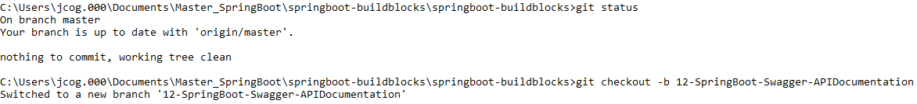

**git branch –a**

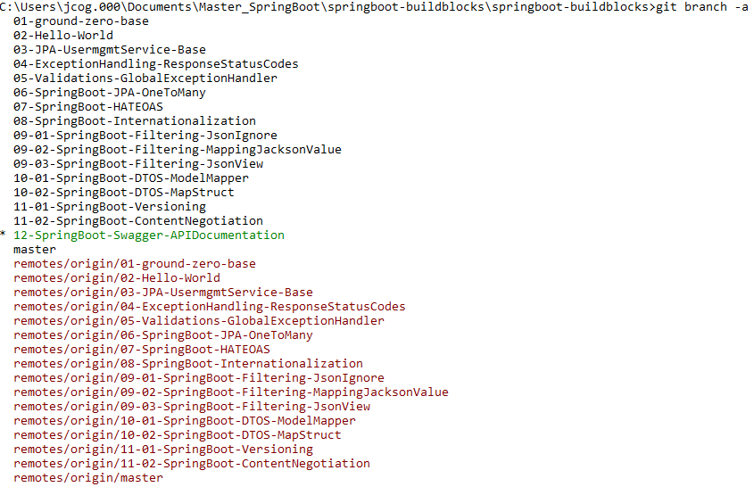

**Add the dependencies:**

**This dependency does not work with springboot 2.6.2**

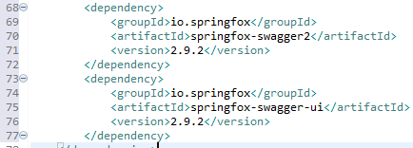

**Used Swagger 3.0 dependencies:**

**Documentation:** [**https://springdoc.org/#features**](https://springdoc.org/#features)

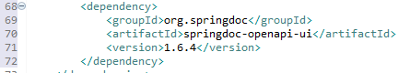

**Create the new SwaggerConfig configuration class:**

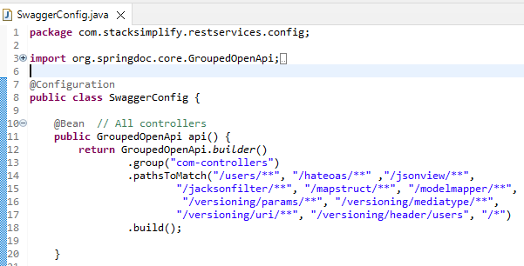

**Swagger Metadata output:**

[**http://localhost:8080/v3/api-docs/com-controllers**](http://localhost:8080/v3/api-docs/com-controllers)

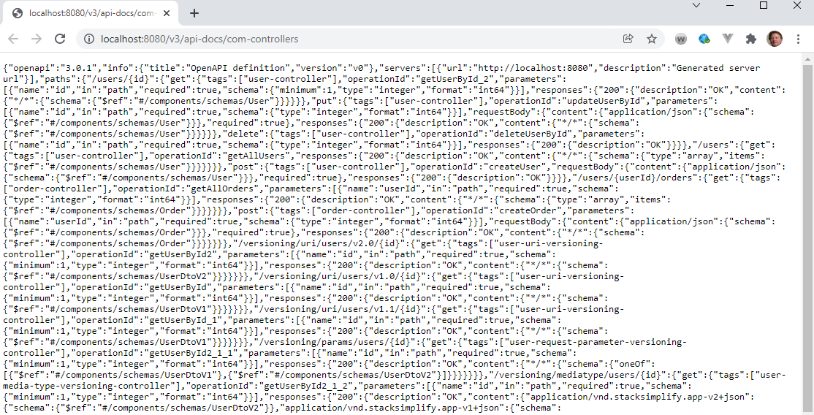

**Swagger UI URL output:**

[**http://localhost:8080/swagger-ui/index.html**](http://localhost:8080/swagger-ui/index.html)

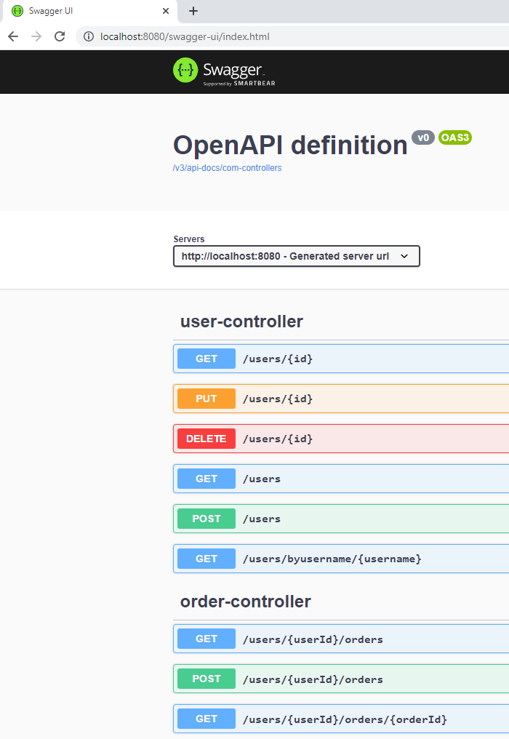

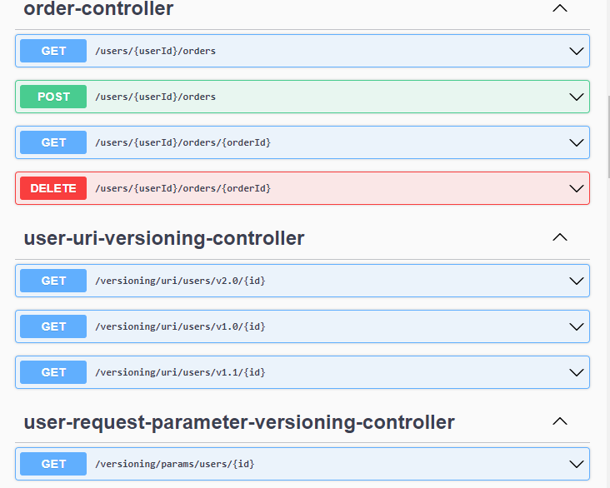

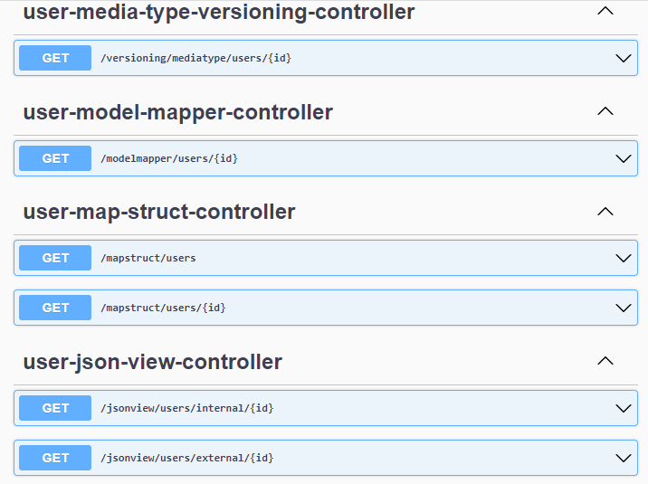

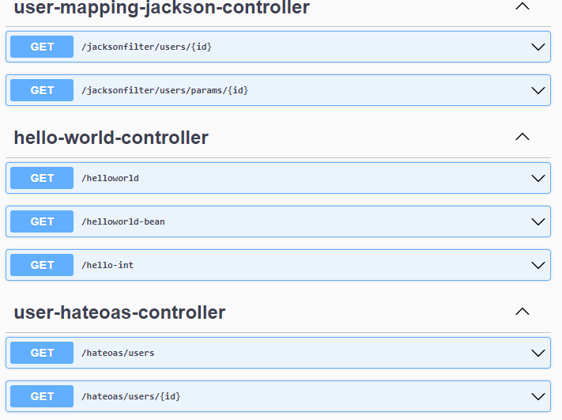

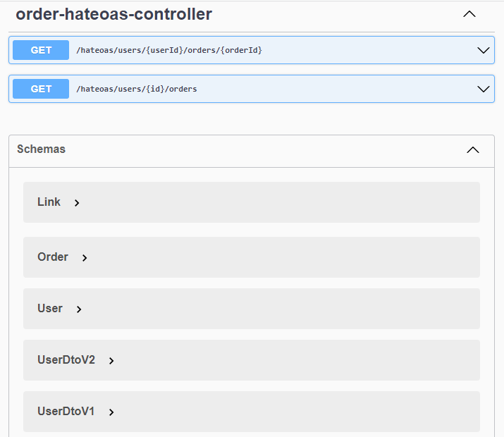

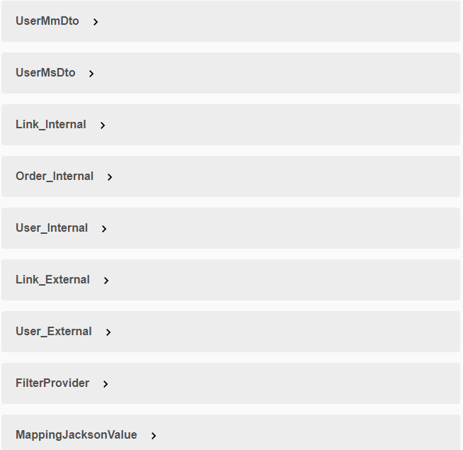

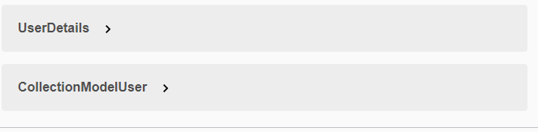

**Open GET /helloworld**

**Testing with curl:**



**Or use application.properties for swagger output if only one Docket:**

springdoc.packagesToScan=com.stacksimplify.restservices, com.stacksimplify.restservices.Hello

springdoc.pathsToMatch=/users/**, /hateoas/**, /jsonview/**, /jacksonfilter/**, /mapstruct/**, /modelmapper/**, /versioning/params/**, /versioning/mediatype/**, /versioning/uri/**, /versioning/header/users, /*

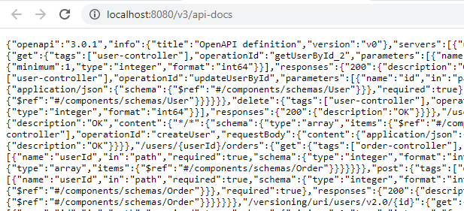

[**http://localhost:8080/swagger-ui/index.html**](http://localhost:8080/swagger-ui/index.html)

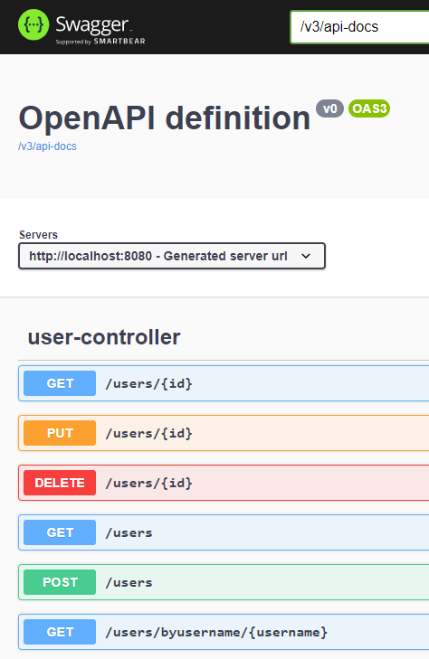

**OpenApi info added:**

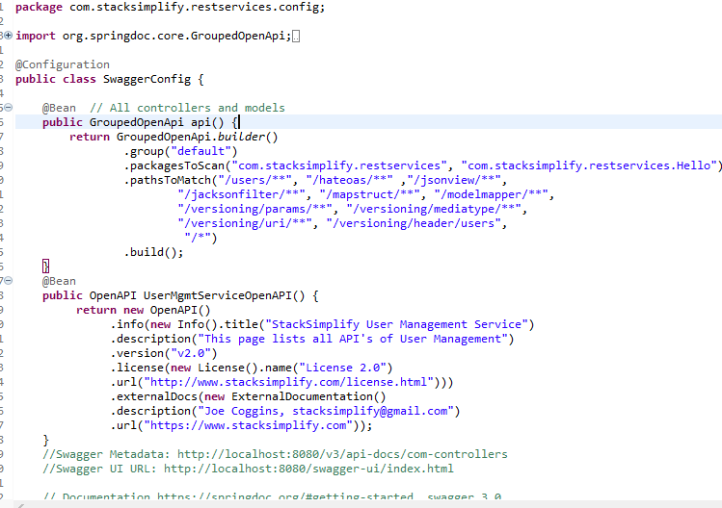

**Display:**

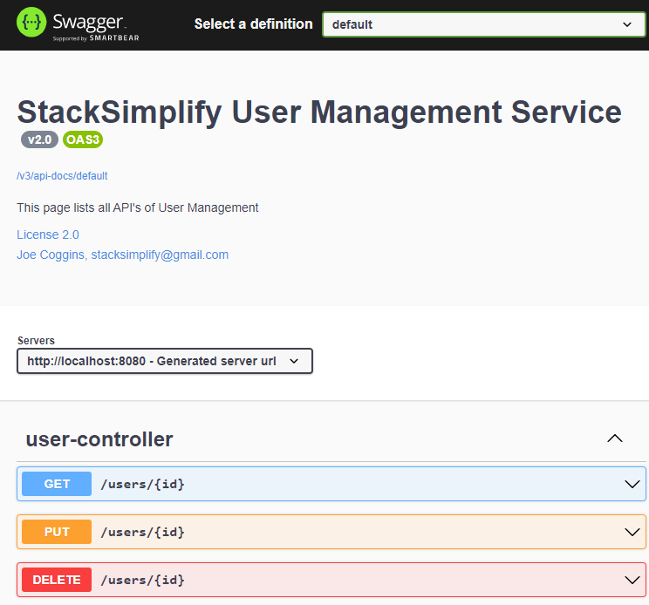

**Reduce the packages to the base package and path to “/users”**

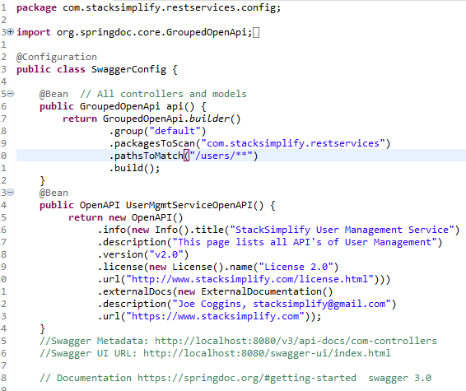

**Output:**

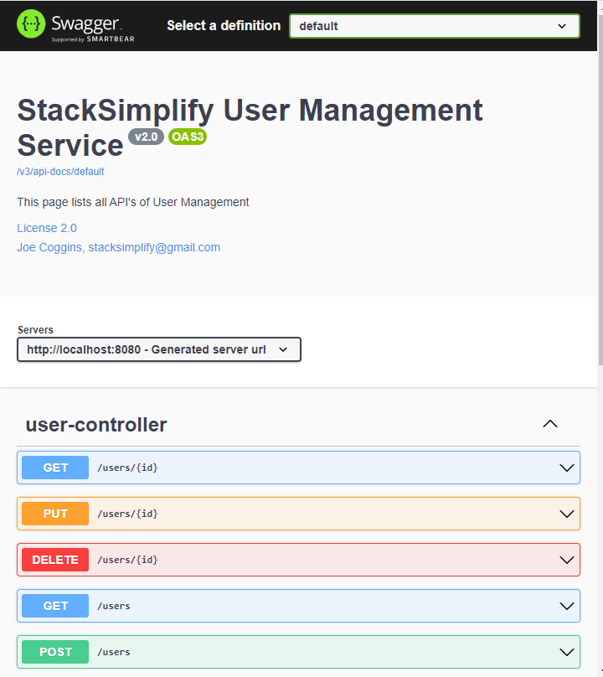

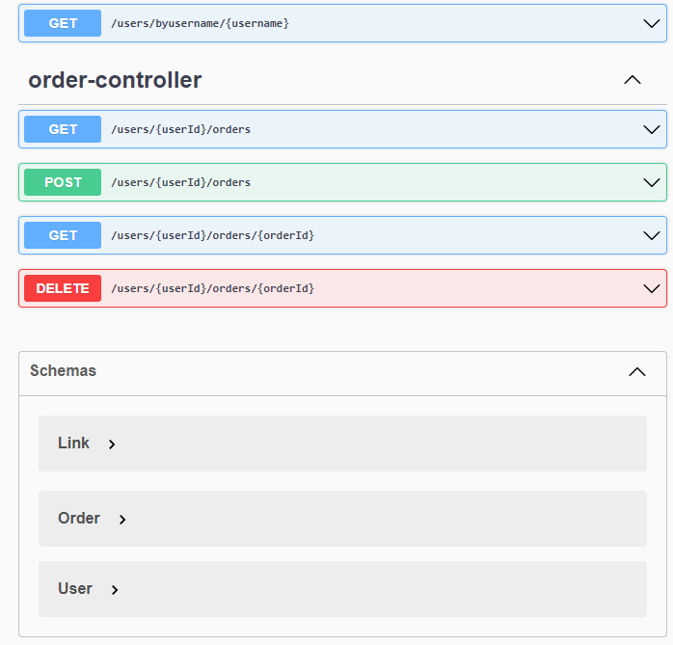

**Copy the OpenDoc Api:**

**Browse to** [**https://editor.swagger.com**](https://editor.swagger.com)

**Paste the code in the Editor Box:**

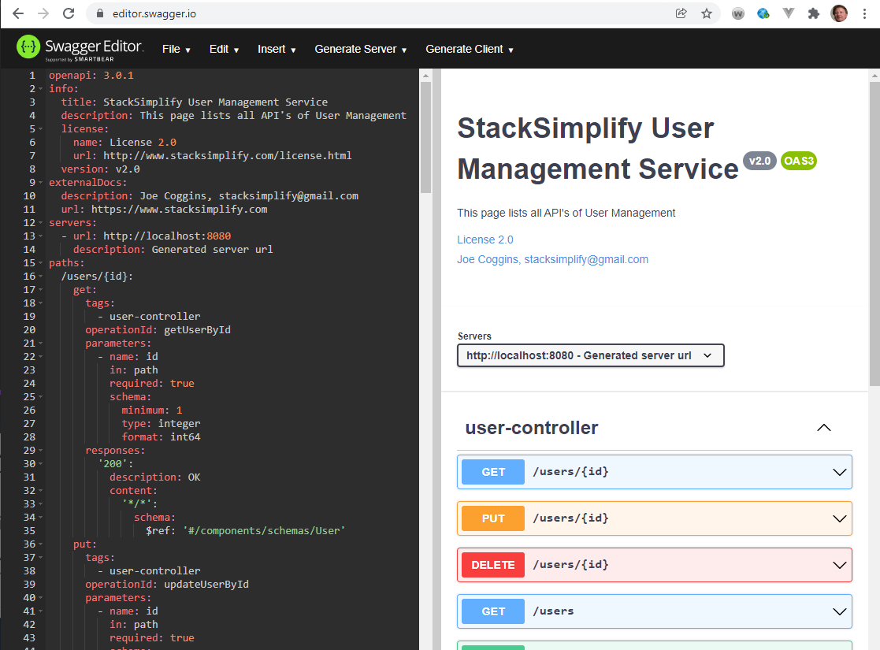

**There are no errors to fix in the code:**

**Test GET /users using REST client Swagger:**

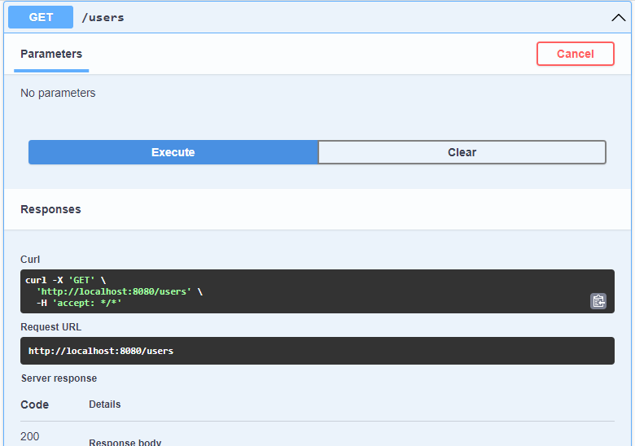

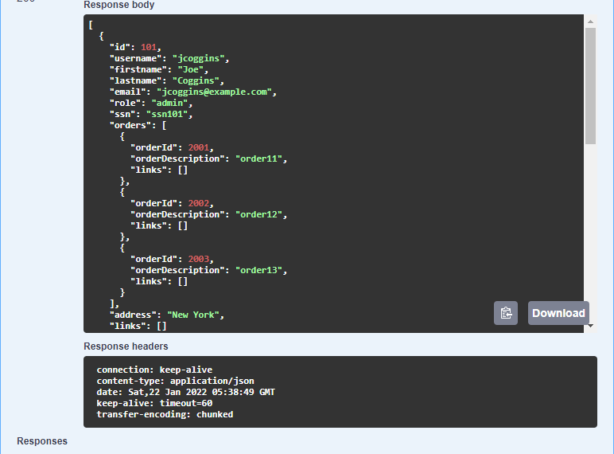

**Test GET /users/{id} using REST client Swagger:**

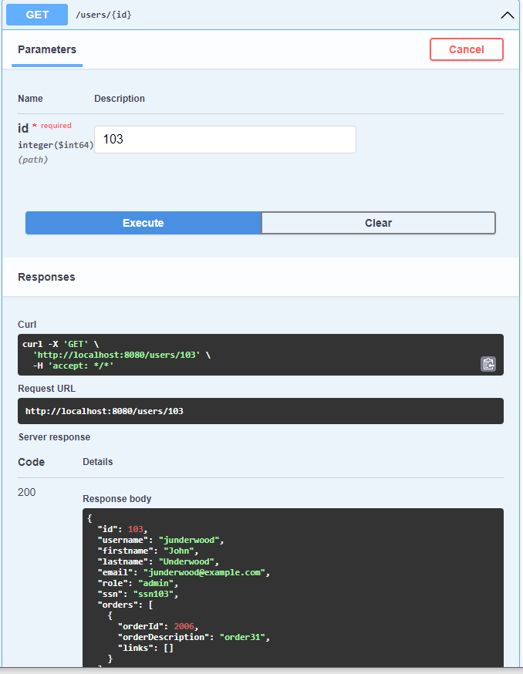

**Add JSR Validation max = 50 to User Entity**

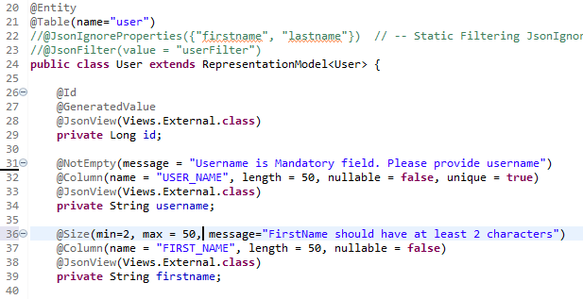

**Add the same validation to Username**

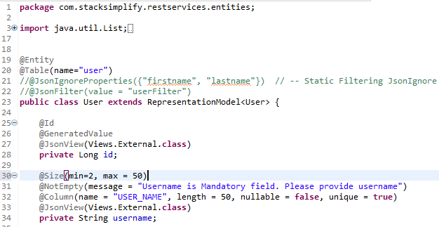

**Validators show up in the model User**

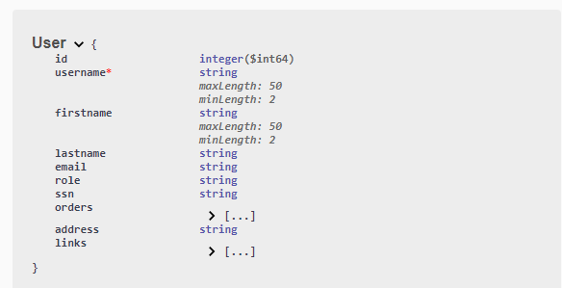

**Add a description at the class level:**

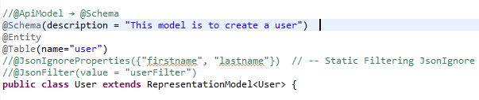

**Display:**

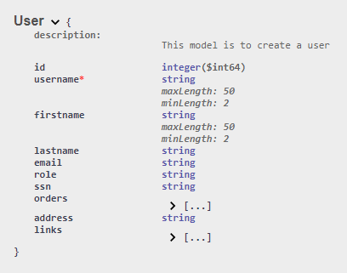

**Add ApiModelProperty or Schema to properties username and id**

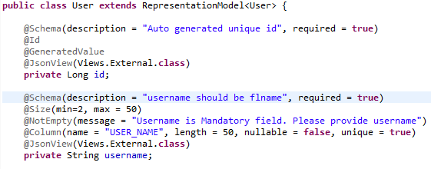

**Display:**

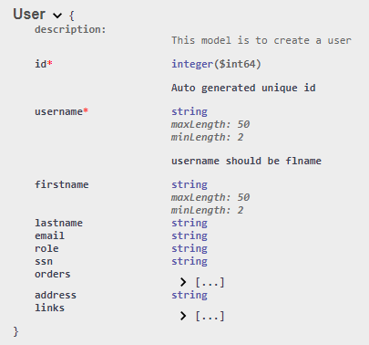

**Provided and example:**

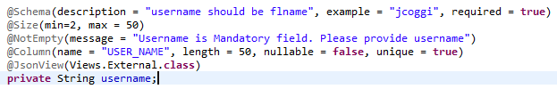

**Display:**

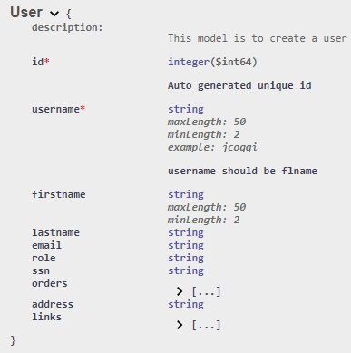

**Label the controller:**

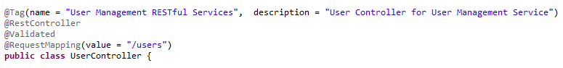

**Display:**

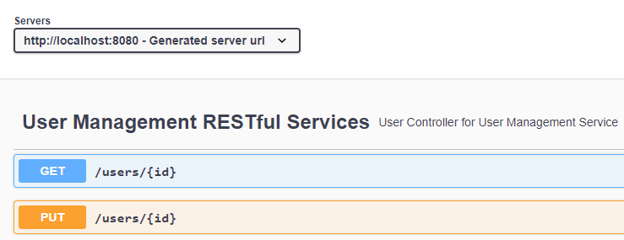

**Replace getAllUsers() method name with more descriptive name**

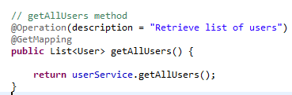

**Display:**



**Replace createUser() method name with more descriptive name**

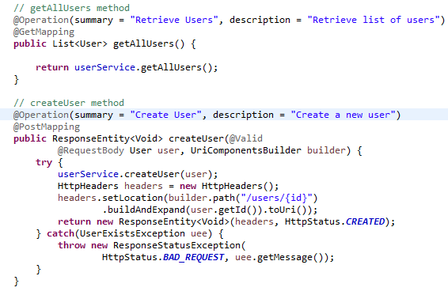

**Display:**

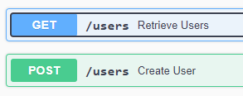

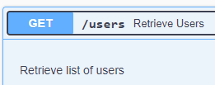

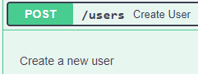

**Comment on the Parameter:**

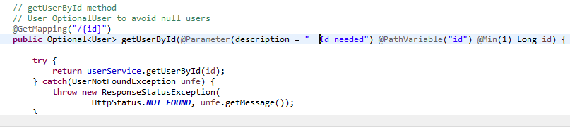

**Display:**

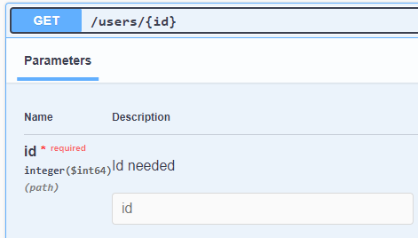

**Adding produces to GetMapping in getAllUsers()**

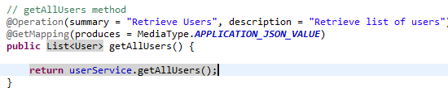

**Displays: application/json**

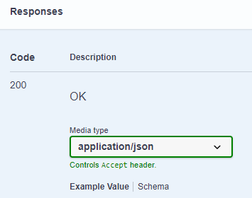

**git status git add . git status**

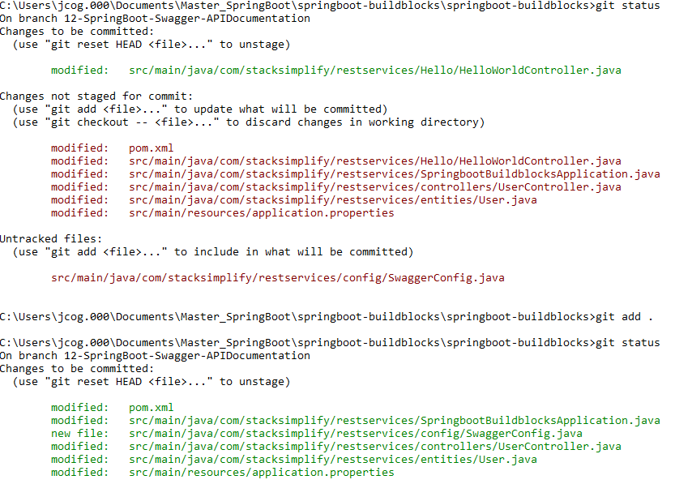

**git commit –m “First Commit”**



**git push origin --set-upstream 12-SpringBoot-Swagger-APIDocumentation**

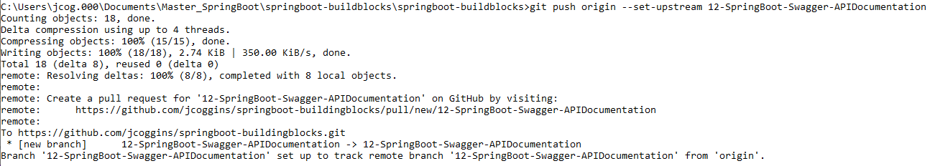

**git checkout master git merge 12-SpringBoot-Swagger-APIDocumentation**

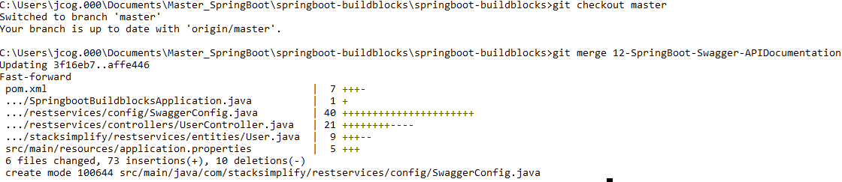

**git push**



**git branch –vva**

